

Madhya Pradesh Electronics Development Corporation (MPSEDC)
State IT Centre, 47-A, Arera Hills, Bhopal, M.P. – 462011,
Phone: +91-755-2518300, Fax: +91-755-2579824
URL: www.mapit.gov.in, Email: info@mapit.gov.in

Parakh – Form Creation Manual

Document Version History
Version | Date | Author | Comments
V_1.0 | 08/10/2025 | Dheeraj Motiyani | Initial draft

Contents

Document Version History 2
MGNREGA Dynamic Form Creation Manual 3
1. Introduction 4
1.1 Purpose 4
1.2 Scope 4
2. Roles & Responsibilities 4
3. Pre-Requisites 5
4. Functional Workflow – Dynamic Form Creation 5
Step 1: Login 5
Step 2: Access Form Creation 7
Step 3: Choose Form Type 7
Step 4: Define Questions 8
Step 5: Assign Form Visibility 10
Step 6: User Creation & Approval 10
Step 7: Asset Creation 12
Step 8: Assign Asset to Department User 12
Step 9: Fill Forms on Mobile Interface 13
5. Validation & Exception Handling 15
6. Compliance & Audit Guidelines 15

Dynamic Form Creation Manual
Version: 1.0
Prepared for: Department
Prepared by: Parakh
Date: 06-Oct-2025
CMMI Maturity Level: 5 – Optimizing

1. Introduction

1.1 Purpose
This Dynamic Form Creation Manual provides a detailed guide for department administrators to create and manage Dynamic Forms within the Department on District GIS Application. The forms are designed to streamline inspections, surveys, and citizen feedback collection.

1.2 Scope
The manual covers:
- Form Creation
- Form Updation
- Question Creation
- Question Updation

2. Roles & Responsibilities
State Admin (For Example:- MGNREGA Admin):
Configure system
Create initial department specific forms & assign permissions
Department Admin:
Create department-specific forms
Approve/reject users

3. Pre-Requisites
Valid MGNREGA Admin login credentials
Mobile application installed (District GIS Parakh)
Internet/Data connectivity

4. Functional Workflow – Dynamic Form Creation

Step 1: Login
Login with Admin Credentials (For example:- manregaadmin) (These are Department admin credentials)
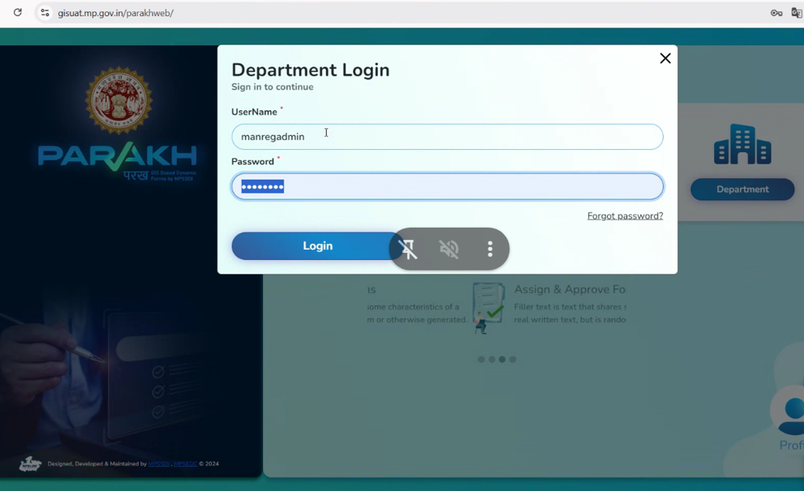

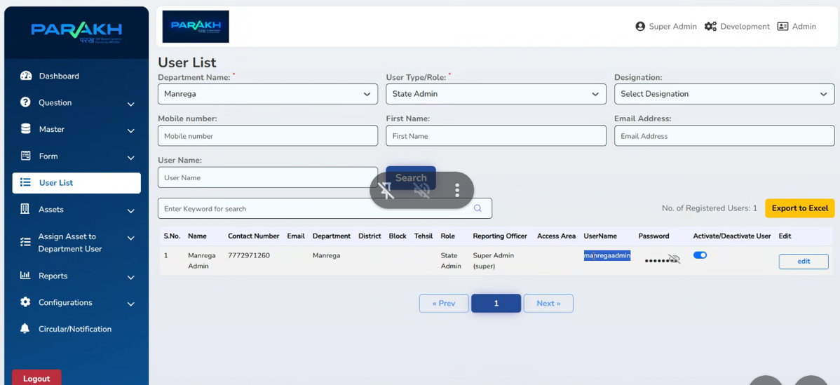
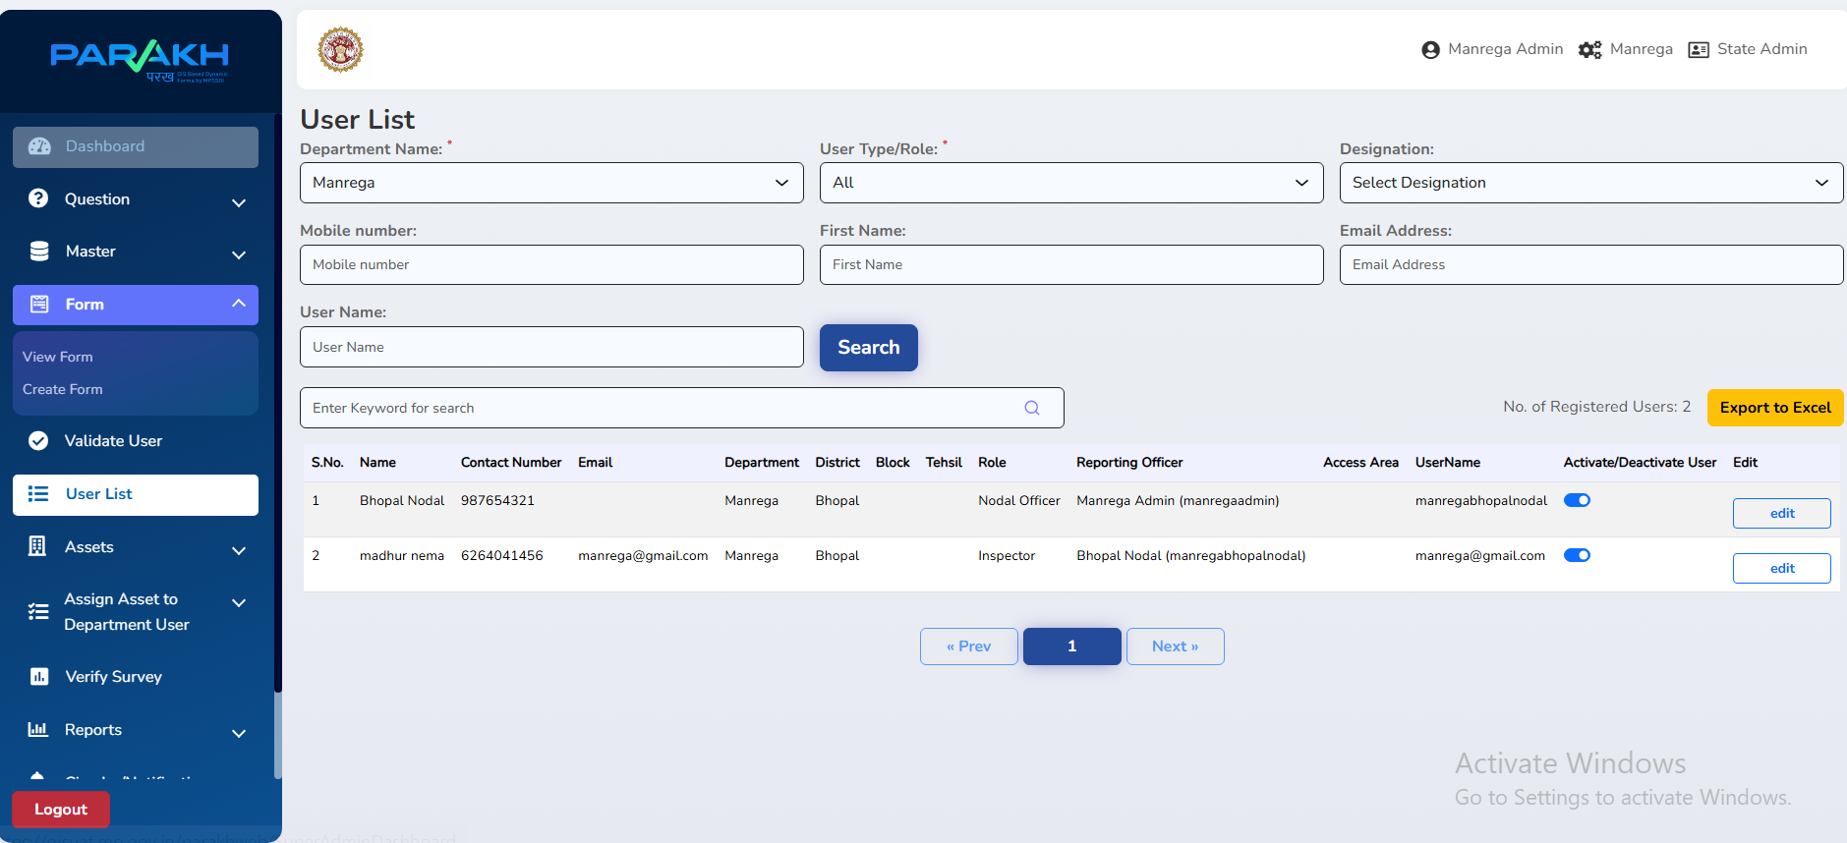

Step 2: Form Creation Steps
- Login to Department Admin (For Example:- manregaadmin)
- Following can be format of the syntax ( <<department_name>>admin )
- Navigate to Modules → Department General Form / Inspection
- Under Form Section
- View Form
- Create Form
  - Select Create Form
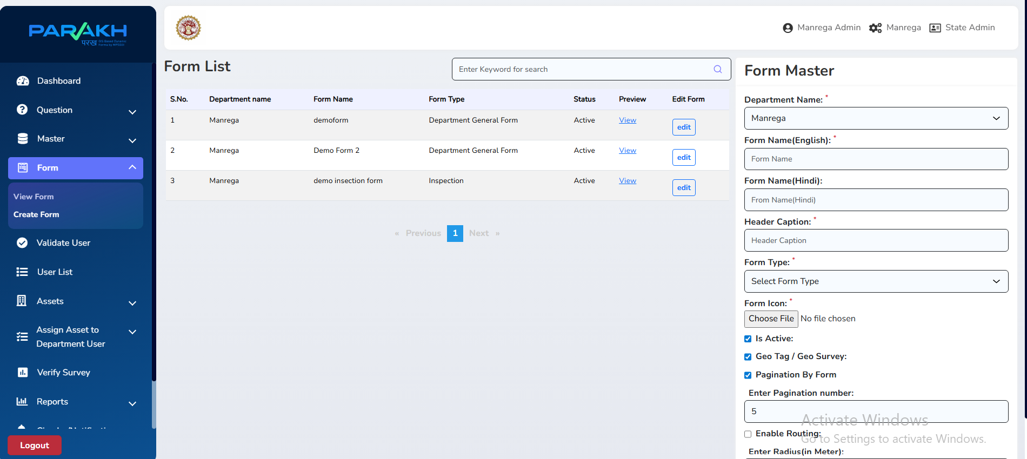

Form Master have following entries:-
- Department Name: Create Form under State Admin ( provide Department name under which it will go ).
- Form Name(English or Hindi):
- Header Caption:
- Form Type:
  - Data Collection / Survey Form (Daily/Frequent)
  - Department General Form
  - Inspection Form
  - Questionnaire Form (Currently not in use)
  - Survey (Currently not in use)
- Form Icon
- Ticket checkboxes – Is Active, Geo Tag, and Pagination
- Enter Pagination Number
- Enter Radius
- Add the Form

- Choose Form Type

- Data Collection / Survey Form (Daily/Frequent)
- Survey or Inspection conducted on a particular asset in a district.
- Users/Field Officer or Inspectors perform survey or inspection and collect data on that particular asset in a district.
- Department General Form
  - For department-level inputs
- Citizen General Form
  - Open for all citizens
- Inspection Form
  - Linked with Data Collection (One-time surveys)
- Questionnarie Form (Currently not in use)
- Survey Form (Currently not in use)

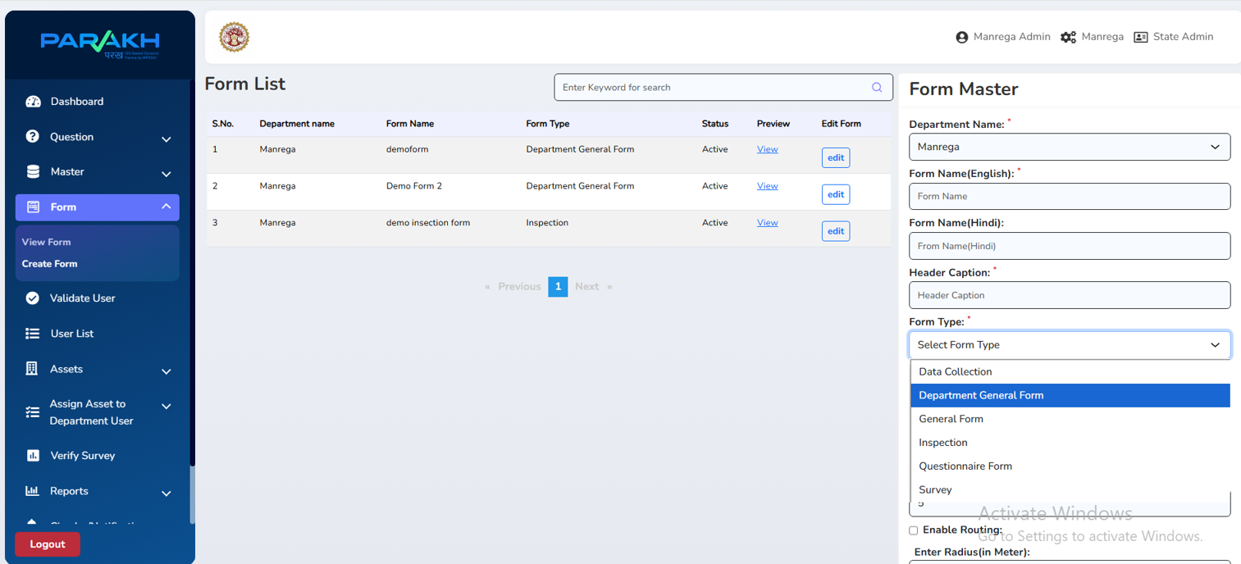

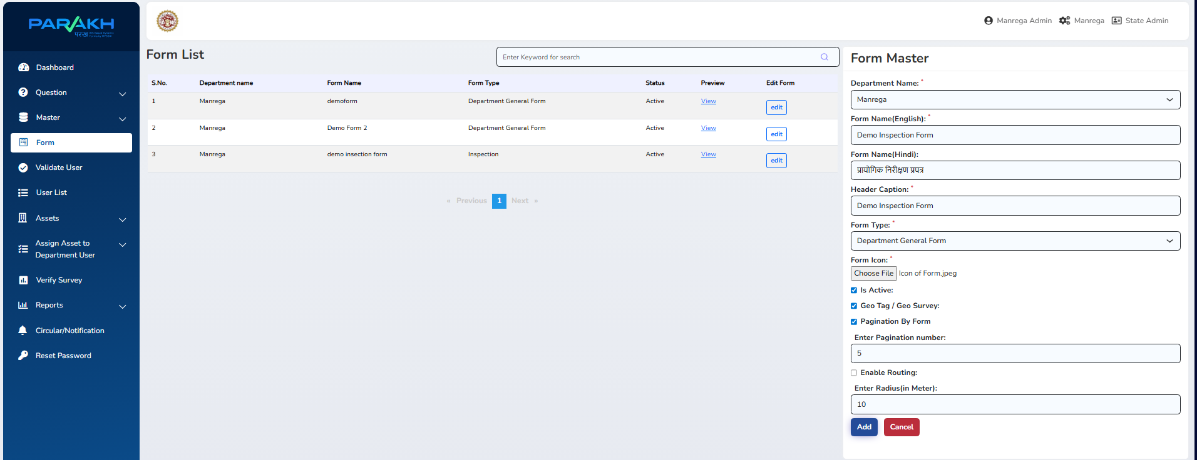
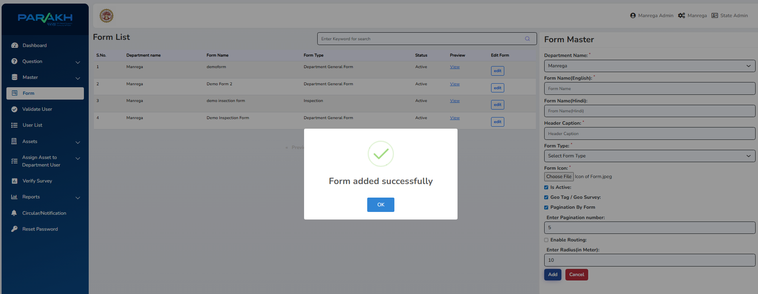

Step 4: Add Questions
- Now, Under Question Tab - Select Create Question
- Add Main Question (e.g., "Is the work completed on time?")
  - Department Name:
  - Form Name:
  - Question Type: ( Below are the following types)
    - Label
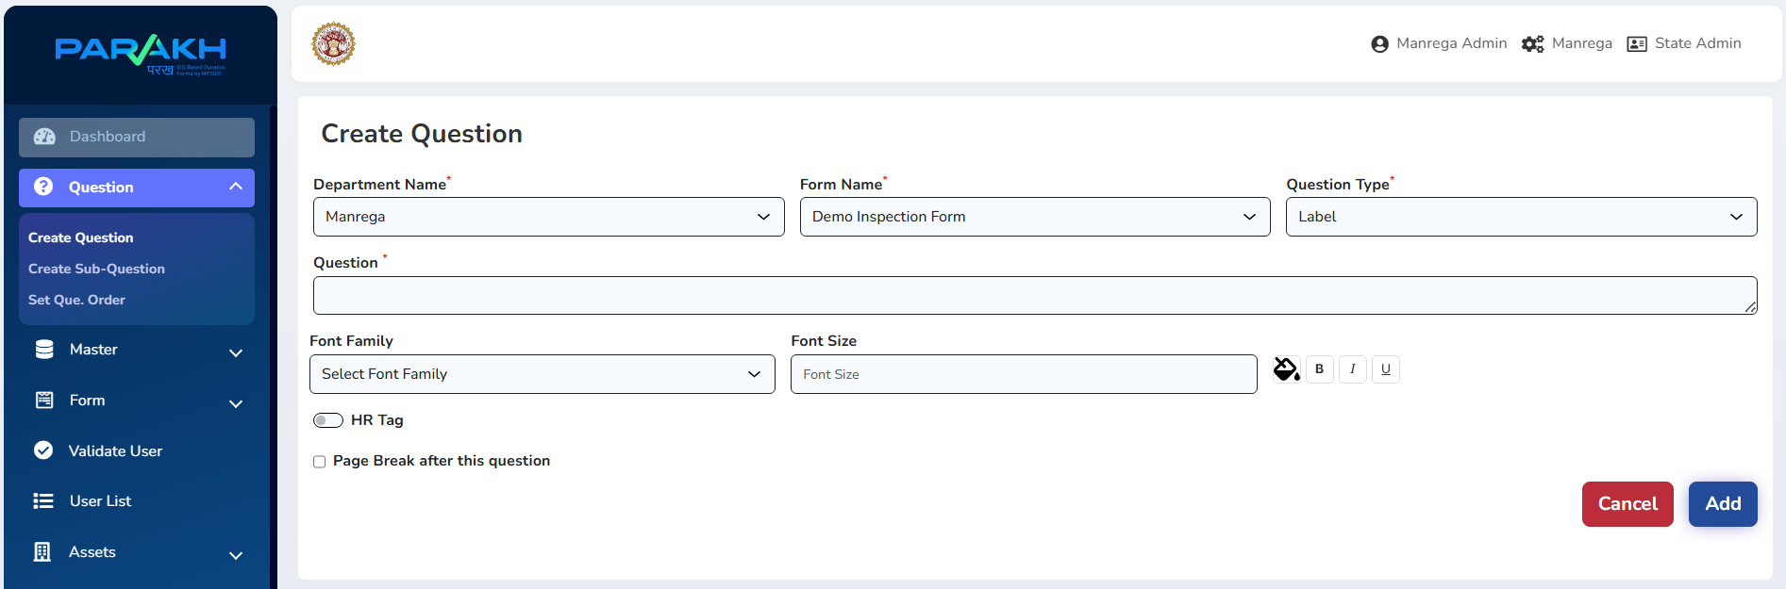
    - Dropdown List Control
    - Radio Button
    - Text
    - Check Box
    - Document Files
    - Image or Video files
    - Dropdown List – Agency, Brand, Model
    - Location
    - Button Add more Records
    - Dropdown List – Gov Department, Sub Gov Department
- Add Sub Questions (e.g., "If No, specify reason")
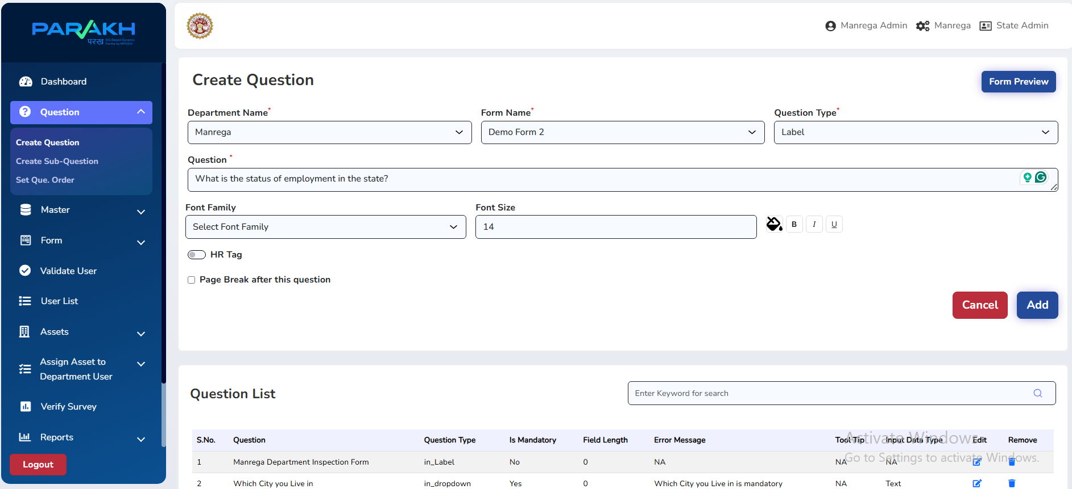
FORM PREVIEW
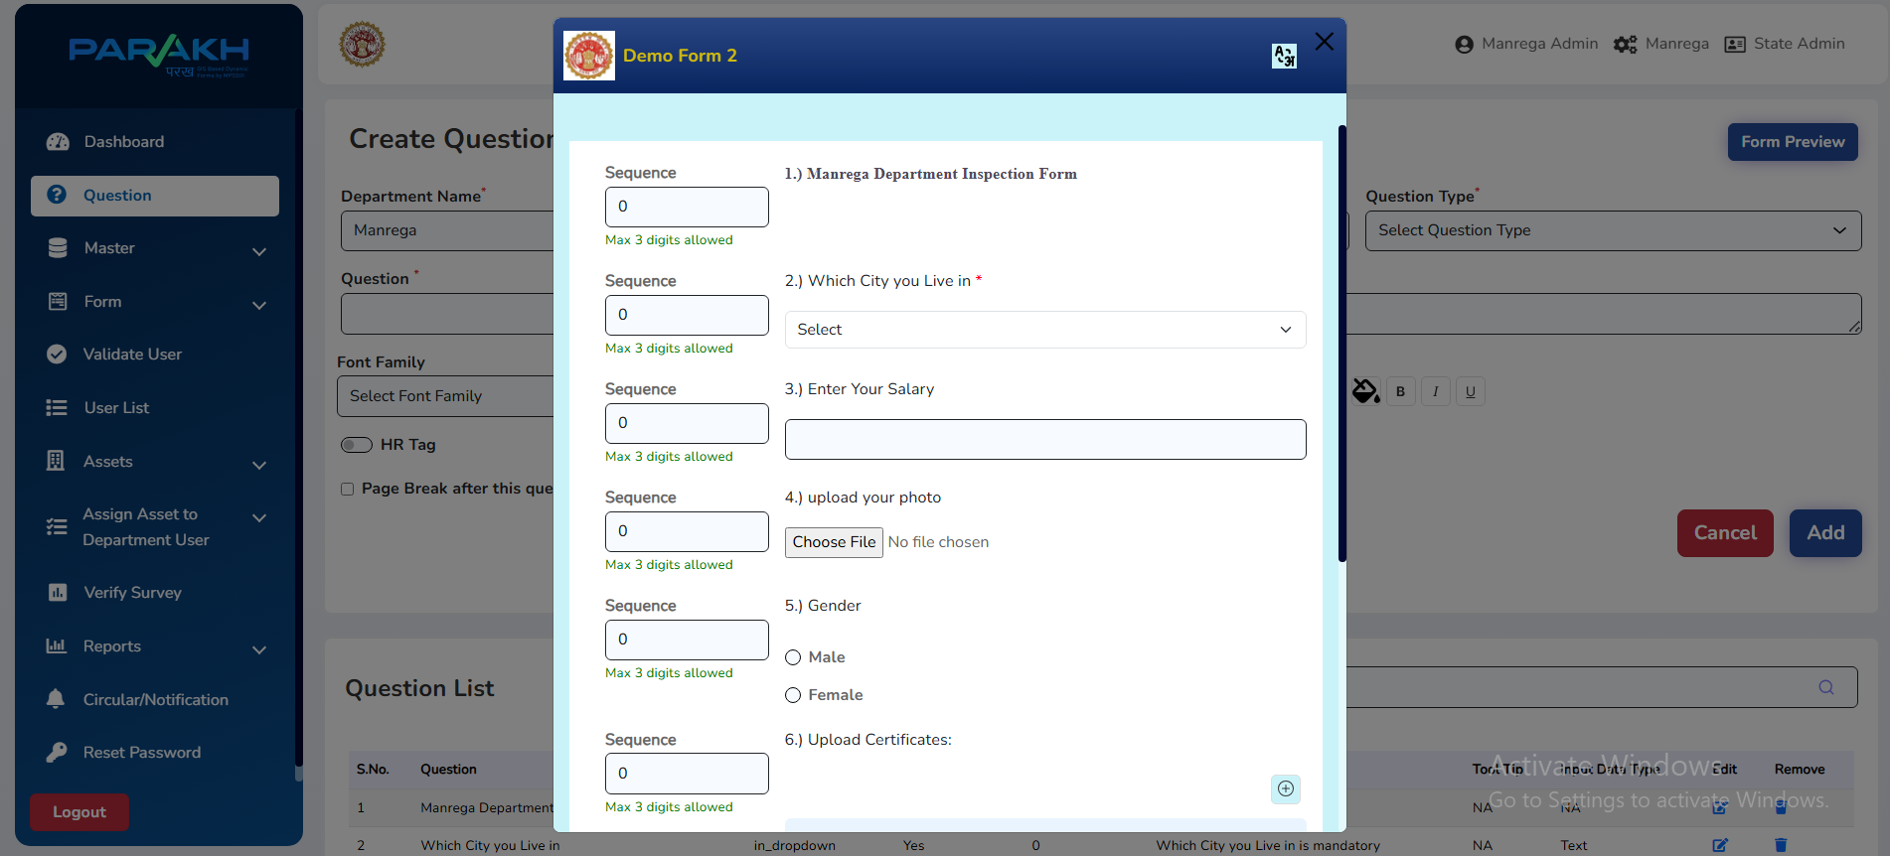
SUB QUESTION CREATION
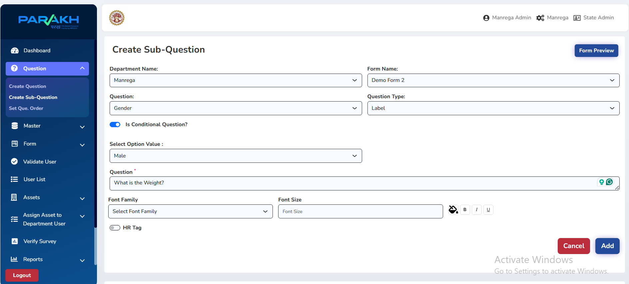

Step 3: Open New Form created – “Demo Inspection Form”

Step 5: Assign Form Visibility
Define who can access the form:
- Department Users
- Inspectors
- Citizens

Step 6: User Creation & Approval
- Super Admin → Create User
- Nodal Officer → Approve User after validation
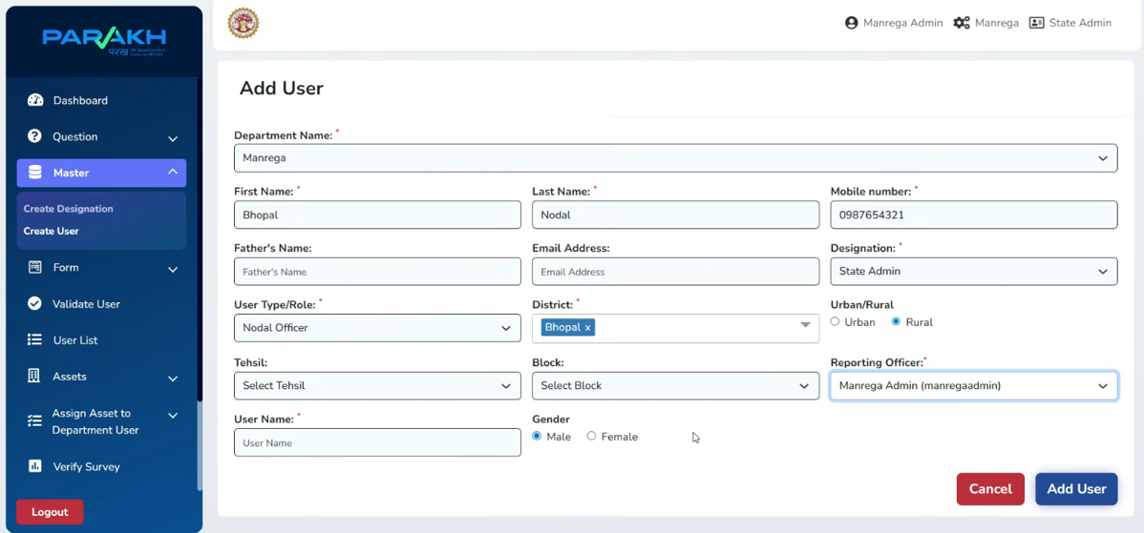
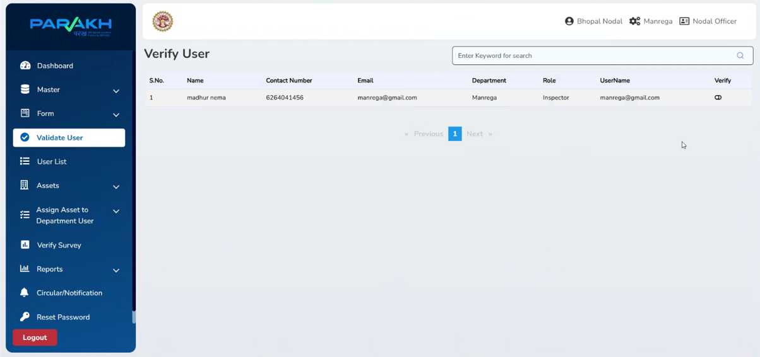
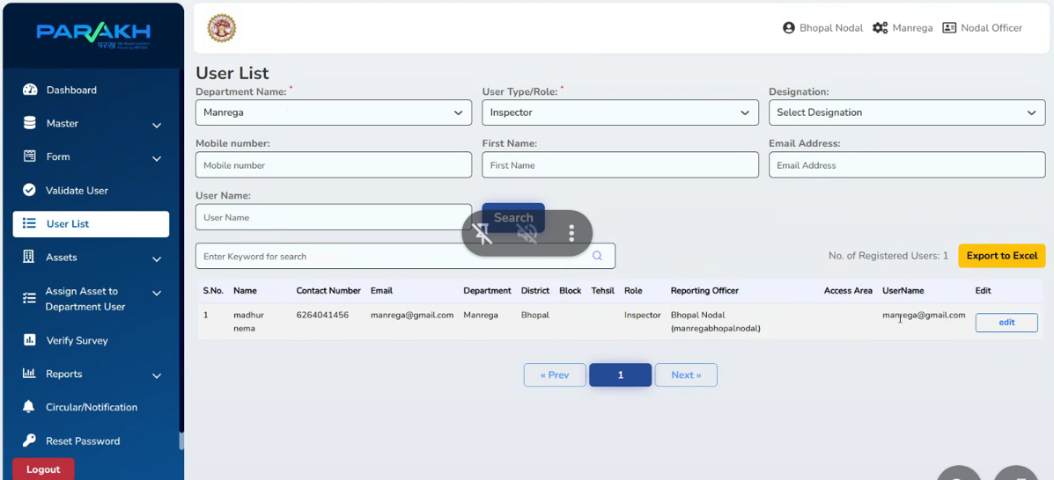

Step 7: Asset Creation
0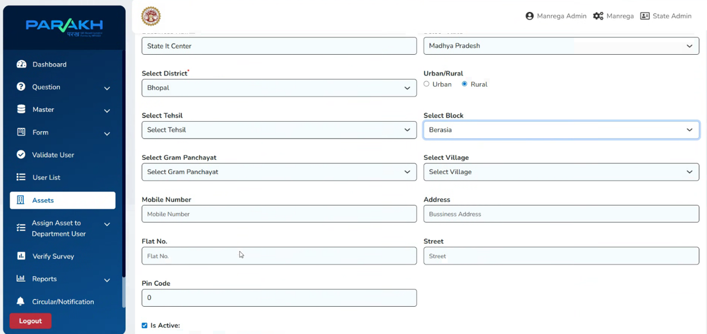

Step 8: Assign Asset to Department User
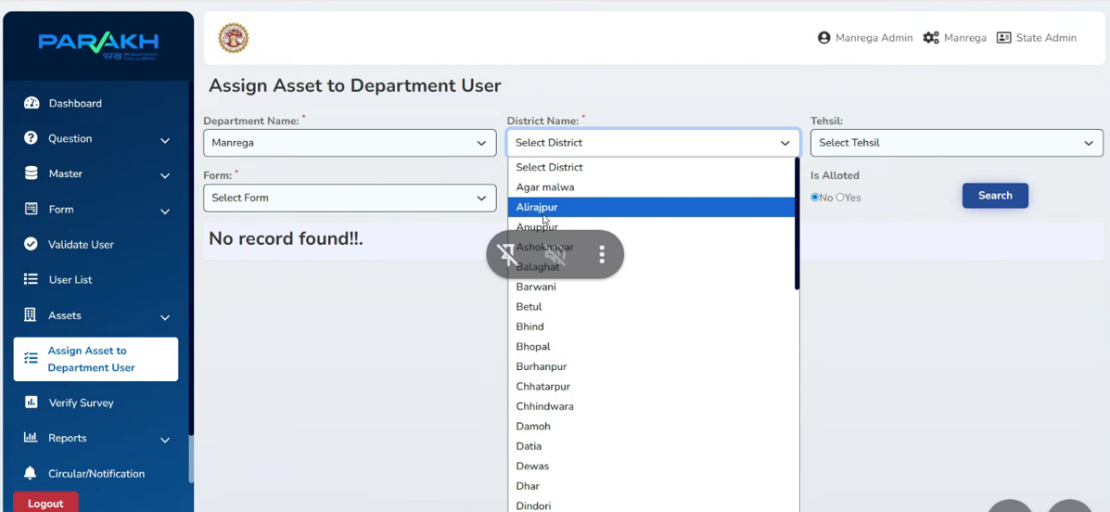

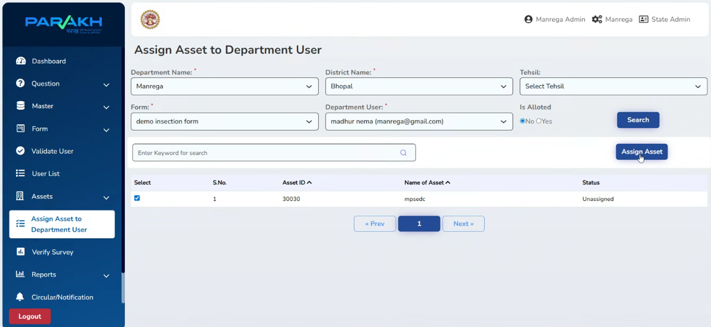

Step 9: Fill Forms on Mobile Interface
- Forms are available to mobile users based on type of person (Inspector, Citizen, Department staff)
- Data submitted is automatically collected in central database.
Dynamic Form Created (Filling) Steps on Mobile Interface:

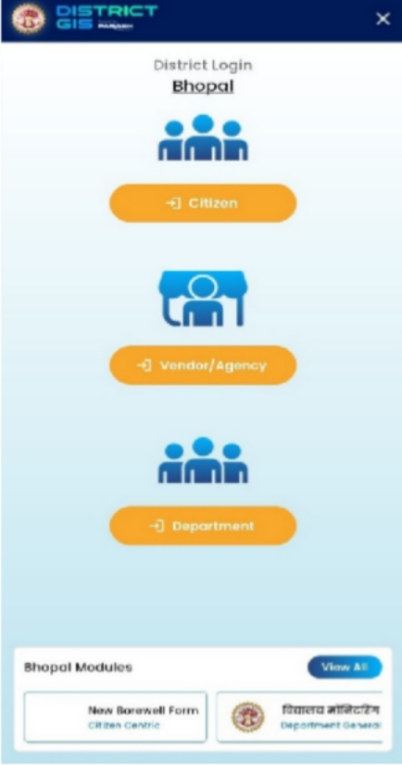
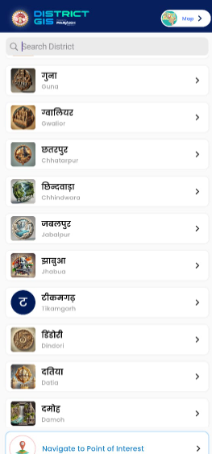
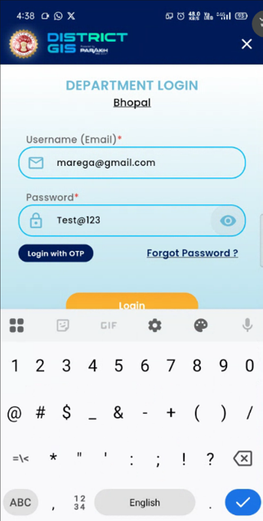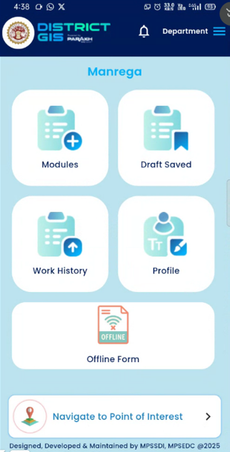

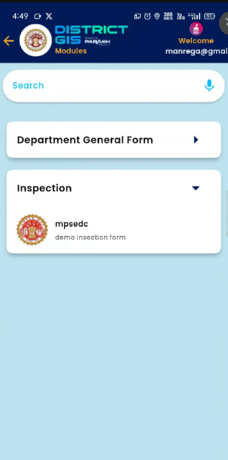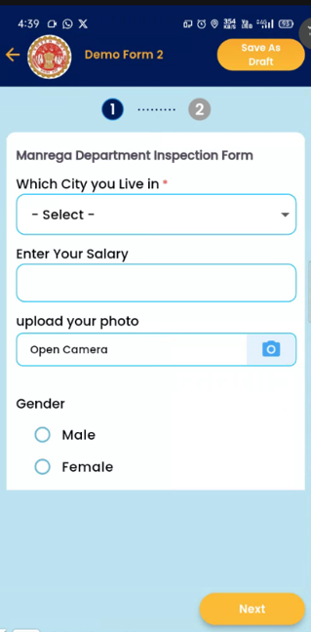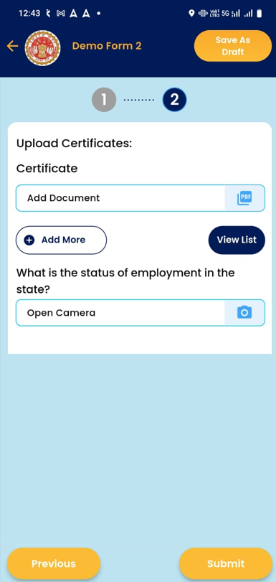

5. Validation & Exception Handling
Form Validation Rules
- Mandatory fields must be completed before submission
- Duplicate entries flagged
- Invalid user attempts logged
- Exception Handling
  - If survey data is incomplete → system prompts to re-enter
  - If user not approved → cannot access forms
  - If network failure → data stored offline & synced later

